
WEDE5020
Assessment Second Proposal
Njabulo Asanda Sithole ST10515615 | 3/18/26 | WEDE5020

Table of Contents
1. Organisation 2
2. Website Goals and Objectives 2
3. Current Website Analysis 3
4. Proposed Website Features and Functionality 3
5. Design and User Experience 4
6. Technical Requirements 4
7. Timeline and Milestones 5
8. Budget 5
9. References 6
10. Wire frame………………………………………………………………………………………………7
11. Site Map…………………………………………………………………………………………………8

1. Organisation Overview
Shoprite Holdings
- “Shoprite Holdings is the largest supermarket retailer in Africa and has its origins in South Africa. The company was founded in 1979 when a small group of investors purchased eight grocery stores in the Western Cape.” (Shoprite Holdings, 2025)
Mission
- “Our mission is to deliver low prices in a world-class shopping environment to customers across the African continent.” (Shoprite Holdings, 2025)
Vision
- “To be Africa’s most profitable omnichannel retailer.” (Shoprite Holdings, 2025)
Target market
- Shoprite’s target audience is for lower to middle-income consumers.

2. Website Goals and Objectives
- The main goal of the website is to help the company sell its products in its stores by using online shopping.
- The website wants to make selling products easy and user-friendly.
- The website needs to work well on every device.

3. Current Website Analysis
  - Strengths
- The Shoprite brand is internationally known.
- It shows product and specials information.
- The website shows locations of Shoprite branches.
  - Weakness
- The website is hard to use.
- The website is also hard to use for online shopping.
- The website is not user-friendly on a mobile device

  - Areas to improvement
- I’ll put a search bar on the website.
- I’ll put a way to buy things on the website.
- I’ll make the website work on every device.

4. Proposed Website Features and Functionality
- The Home page will have things like current promotions, products on special, and important announcements.
- The About Us Page will include the history of Shoprite, its mission, vision, and values.
- The Product/Services Page will show products categorised. And there will be a search bar.
- The Online Shopping functionality will help customers to make an account and buy products online.
- The Contact Page will have contact information like phone numbers, email addresses, and store locations.

5. Design and User Experience
  - Colour Scheme
- red, white, and yellow.
  - Typography
- Headings will be bold to highlight categories and promotions.
- Body text should be simple
- Font size will be big enough for mobile devices.
  - Layout and Design
- The home page will show products, specials, and categories.
- Product pages should have images, a price, and a description of the products.
  - User Experience
- Website will be easy to use
- The website will have a Home, Product, About, and Contact.
- The layout will work well on every device

6. Technical Requirements
  - Hosting Requirements
- The website will use cloud hosting to handle traffic and provide good performance. Furthermore, the hosting platform should provide fast loading and strong security features.
  - Domain Name
- The domain name should be www.shoprite.co.za because it is professional, easy to remember, and reflects the brand's name.

  - Programming language
- The website will use HTML, CSS, and JavaScript.
  - Data Requirements
- The website will use MySQL to store product information, customer data, and transaction records.
  - Security Requirements
- For protection from cyber threats. The website will use SSL encryption, a secure payment gateway, and a firewall.

7. Timeline and Milestones
 | Duration
Planning & Research | 1-2 weeks
Design | 2-3 weeks
Development | 3-4 weeks
Testing | 1-2 weeks
Maintenance | 1 week

8. Budget
Service | Price
Planning & Research | R 3 344,85
Website Development | R 6 686,48
E-commerce Integration | R16 716,20
Testing & Quality Assurance | R4 573,74
Deployment & Hosting Setup | R1 672,35
Total Cost | R 32 993,62

  - Maintenance Fee
R 2511,90 PM
Payment Terms
- 50% deposit before project start

9. References
Shoprite Holdings. (2025 Our purpose, values, and vision. Available at: https://shopriteholdings.co.za/group/our-purpose-values.htm (Accessed:19 March 2026)

Wire Frame
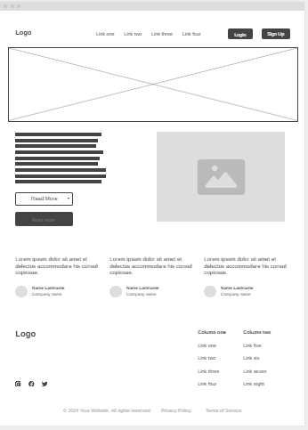

Site Map
